

**US BABY NAMES REPORT (SQL)**

***1. Most Popular Baby Names of Each Decade and Their Changes Over Time?***

SELECT name, gender,

FLOOR(year / 10) * 10 AS decade,

COUNT (*) AS total_count

FROM names

GROUP BY

name, gender, decade

ORDER BY decade ASC, total_count DESC;

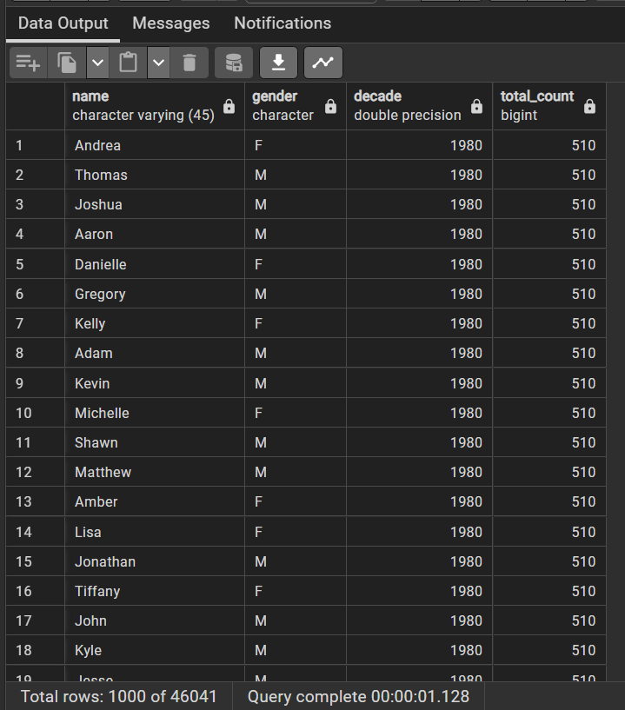

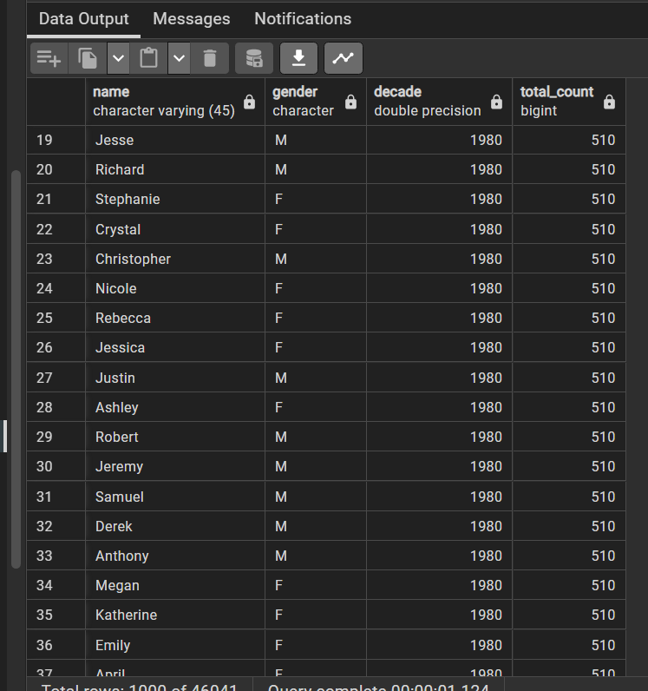

***2.******Baby Names With Biggest Jumps and Drops in Popularity?***

WITH NameRanks AS (

SELECT name, gender, year,

COUNT(*) OVER (PARTITION BY year, gender

ORDER BY names DESC) AS ranK FROM names ),

RankChanges AS (

SELECT name, gender, year, rank,

LAG(rank) OVER (PARTITION BY name, gender

ORDER BY year) AS prev_rank

FROM NameRanks)

SELECT name, gender, year,

(prev_rank - rank) AS rank_change

FROM RankChanges

WHERE prev_rank IS NOT NULL

ORDER BY rank_change DESC;

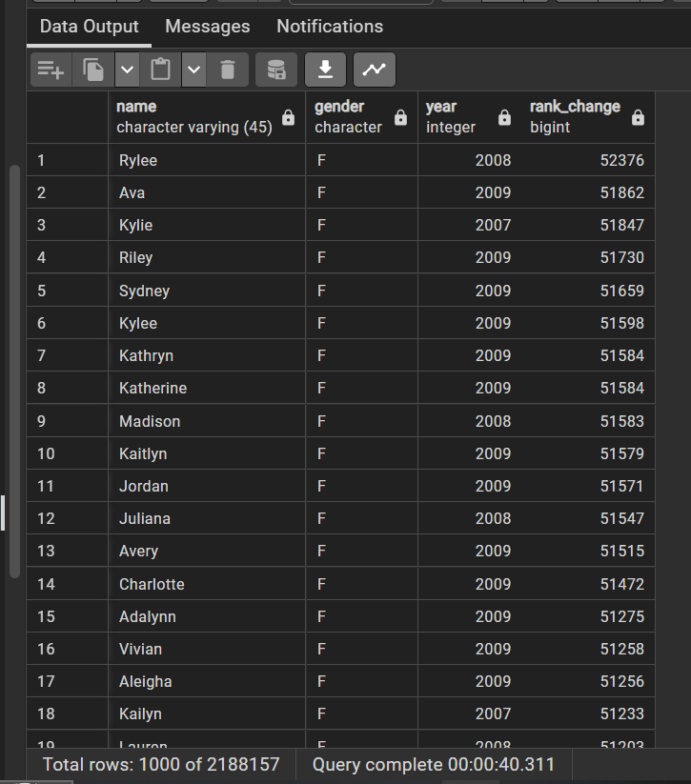

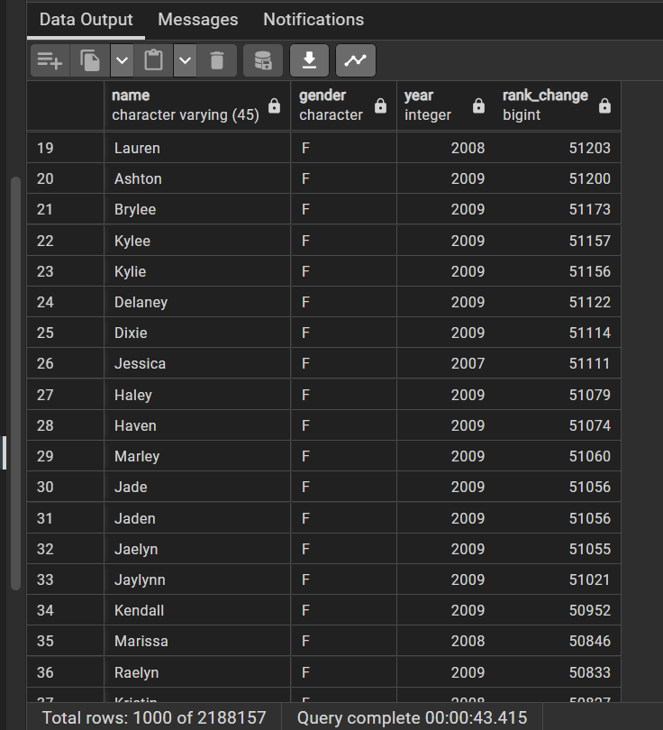

***3. Differences in Names for Boys vs. Girls vs. Both Over Time?***

SELECT name, gender,

count(*) AS total, year

FROM names

GROUP BY name, gender, year

ORDER BY year, total DESC;

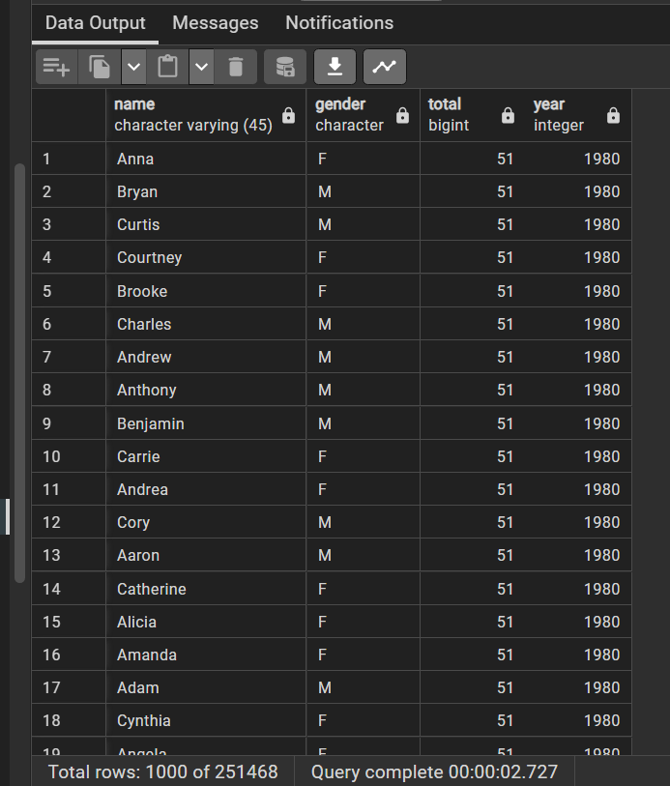

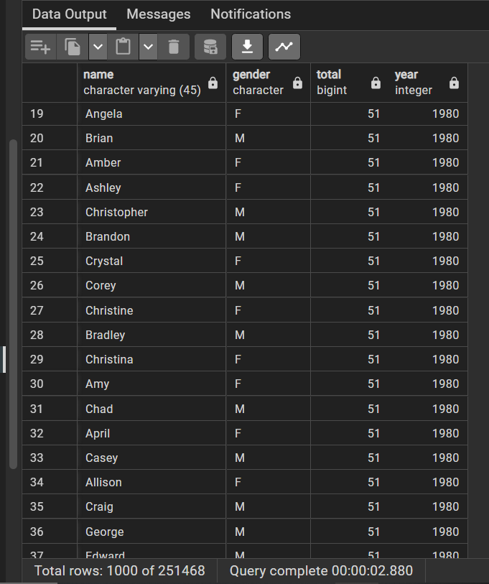

***4. Differences in Baby Name Popularity Based on Region in the United States?***

***--using state***

SELECT state, name, gender,

count(*) AS total_count

FROM names

GROUP BY state, name, gender

ORDER BY state ASC, total_count DESC;

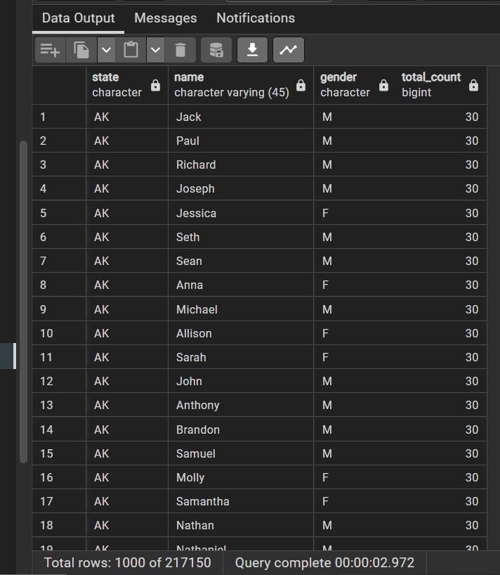

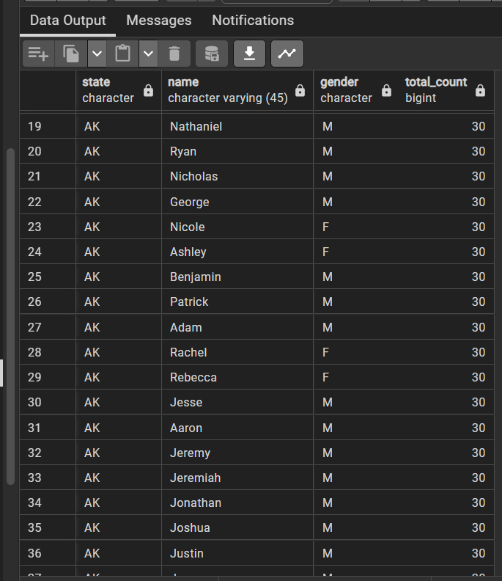

***--using region***

SELECT

CASE

WHEN state IN ('CT', 'ME', 'MA', 'NH', 'RI', 'VT', 'NJ', 'NY', 'PA') THEN 'Northeast'

WHEN state IN ('IL', 'IN', 'MI', 'OH', 'WI', 'IA', 'KS', 'MN', 'MO', 'NE', 'ND', 'SD') THEN 'Midwest'

WHEN state IN ('DE', 'FL', 'GA', 'MD', 'NC', 'SC', 'VA', 'DC', 'WV', 'AL', 'KY', 'MS', 'TN', 'AR', 'LA', 'OK', 'TX') THEN 'South'

WHEN state IN ('AZ', 'CO', 'ID', 'MT', 'NV', 'NM', 'UT', 'WY', 'AK', 'CA', 'HI', 'OR', 'WA') THEN 'West'

ELSE 'Other'

END AS region, name, gender,

count(*) AS total_count

FROM names

GROUP BY region, name, gender

ORDER BY region ASC, total_count DESC;

